HGS Sediment-Nutrient Module
USER MANUAL

Version 1.0 | July 2026
Table of Contents
1. Purpose and Scope 2
2. Package Contents and System Requirements 3
2.1 Python Version 3
2.2 Packaged Windows Executable 3
3. Quick Start 5
4. Interface Guide 6
4.1 Input Files and Output Location 6
4.2 Browse Buttons 7
4.3 Model Switches Section 7
4.4 Run Control 8
5. Input and Configuration Files 9
5.1 Main Parameter Groups 9
6. Model Switches 10
6.1 Primary Switches 10
6.2 Advanced Switches 10
7. Outputs and File Locations 11
7.1 Main Output Files 11
7.2 Key Station Variables 12
7.3 SSC Interpretation 12
7.4 Nutrient Interpretation 12
8. Mass-Balance Diagnostics 13
8.1 Mass-Balance Fields 13
8.2 Interpreting Mass-Balance Results 13
9. Calibration and Headless Operation 14
9.1 Calibration / PEST Mode 14
9.2 Headless Operation 14
9.3 Disabling the GUI in Source Code 14
9.4 Environment Variable Configuration 14
10. Troubleshooting 16
11. Reproducibility and File Management 17
Appendix A. Run Checklist 18
Appendix B. Recommended Folder Structure 18
Appendix C. Suggested File Naming Convention 19
Appendix D. Notes for Packaged Executable Users 19
Appendix E. Terminology 20

1. Purpose and Scope
The HGS Sediment–Nutrient Module is a post-processing tool designed to work with HydroGeoSphere (HGS) surface-water outputs. The module estimates hillslope sediment delivery, in-channel sediment routing, suspended sediment concentration (SSC), groundwater/surface-water exchange diagnostics, and nutrient loads at a selected monitoring station. The full theoretical background, verification, validation, and model applications are described in xxx.
The graphical user interface (GUI) provides file selection, model switches, run control, and a live terminal window for monitoring model execution. Numerical parameters, calibration values, file paths, and model constants are stored in a single Python configuration file, normally named:
model_config.py

Boundary Treatment Note
In the current routing implementation, sediment reaching terminal channel cells is retained within the modeled routing domain rather than exported beyond the domain boundary. Therefore, the outlet export term may be reported as zero even when the numerical sediment mass balance is closed. Users should interpret outlet export together with deposition, in-channel storage, station-scale sediment loads, and SSC outputs.

2. Package Contents and System Requirements
The module may be distributed either as Python source code or as a packaged Windows executable.

2.1 Python Version
For the Python version, users need Python 3 and the required scientific packages.
Item | Requirement
Python | Python 3.x
GUI | tkinter
Numerical packages | NumPy, pandas
Plotting | Matplotlib
Optional spreadsheet support | openpyxl, if Excel outputs are used
Main program | HGS_Sediment_Nutrient_Module.py
Configuration file | model_config.py
HGS surface output | *.olf.dat
HGS channel file | *.chan.dat
Write access | Permission to create folders, CSV files, maps, and log files

2.2 Packaged Windows Executable
For the packaged Windows version, users do not need to install Python separately. The executable should remain in the same folder as its internal files, example configuration file, documentation, and optional example inputs.
A typical package may include:
File Names
HGS_Sediment_Nutrient_Module_v1.0/ HGS_Sediment_Nutrient_Module.exe
model_config.py
Example Folder
User_Manual.pdf
Output Folder

Users should not move the executable away from the package folder unless all required internal files are moved with it.

3. Quick Start
- Open the module using either the Python script or the packaged executable.
- Confirm the Input/Config File. This file contains model paths, numerical parameters, and switch values.
- Select the HGS OLF Output file. This should be an existing HGS surface-water output file, usually ending in: .olf.dat
- Select the HGS Channel File. This should be the CHAN file corresponding to the same HGS model mesh, usually ending in: .chan.dat
- Select the Output Folder. Results will be written to this folder. If timestamped output is enabled, a new run folder will be created inside it.
- Select the required model switches.
- Click More to review advanced switches if needed.
- Keep Save File Paths and Switches to the Input File Before Running checked if the GUI selections should update the configuration file.
- Click Run Model.
- Use Show Terminal to monitor progress, warnings, and mass-balance messages.
- After completion, open the output folder and review the generated CSV files, maps, figures, and run.log.

4. Interface Guide
The GUI is organized into four main sections, shown below:
- Input Files and Output Location
- Model Switches
- Run Control
- Terminal Log
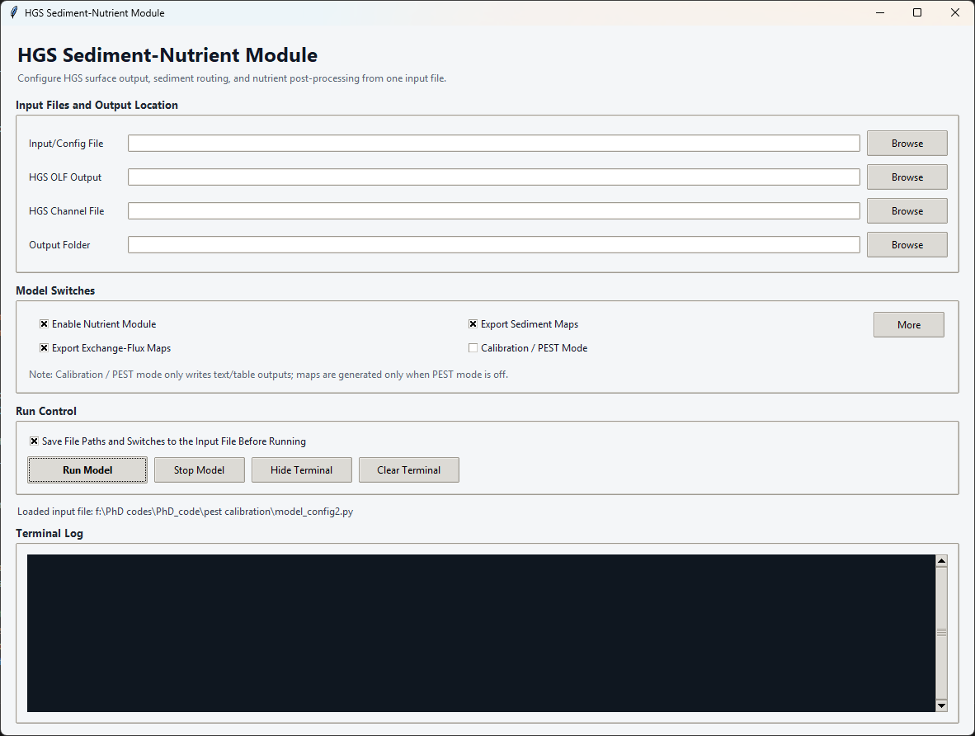

4.1 Input Files and Output Location
This section defines the input files and output directory used by the model.
Field | Purpose | Requirement
Input/Config File | Python configuration file containing paths, switches, and numerical parameters. | Must exist and be valid Python.
HGS OLF Output | HGS surface-water output used for flow, water depth, exchange, sediment, and nutrient calculations. | Must exist and contain compatible saved variables and solution times.
HGS Channel File | HGS channel geometry file used to identify channel cells. | Must correspond to the same HGS mesh.
Output Folder | Parent folder for model results. | Created when possible if it does not exist.
Path Guidance
Absolute paths are recommended for the OLF and CHAN input files. A relative output path is resolved from the directory in which the program is launched.

4.2 Browse Buttons
Each Browse button opens a file or folder picker.
- The Input/Config File button selects a Python configuration file.
- The HGS OLF Output button selects the HGS surface output.
- The HGS Channel File button selects the HGS channel file.
- The Output Folder button selects the parent folder for results.
When a configuration file is selected, the GUI attempts to load saved paths and Boolean switch values from that file.

4.3 Model Switches Section
The Model Switches section controls the main optional functions of the module, including nutrient calculation, spatial map export, calibration mode, sediment-routing options, and diagnostic outputs.
To keep the interface compact, only the primary switches are displayed by default. These include Enable Nutrient Module, Export Sediment Maps, Export Exchange-Flux Maps, and Calibration / PEST Mode. Additional advanced switches are hidden by default and can be displayed by clicking More. After expansion, the button changes to Less; clicking Less hides the advanced switches again.
All advanced switches remain within the Model Switches section. A detailed explanation of each switch and its corresponding configuration variable is provided in Section 6.

4.4 Run Control
The Run Control section contains the buttons used to start, stop, and monitor a model run.
Control | Action
Run Model | Validates inputs, optionally saves GUI selections to the configuration file, and starts the model run.
Stop Model | Requests termination of the running process. Partial outputs may remain.
Show Terminal / Hide Terminal | Shows or hides the live terminal output.
Clear Terminal | Clears the GUI terminal display only. It does not delete run.log or output files.

5. Input and Configuration Files
The configuration file is an executable Python file. It stores input paths, output folder settings, model switches, and numerical parameters. Users should not remove required variables from the configuration file.

5.1 Main Parameter Groups
The configuration file contains the numerical parameters and station settings required by the module. The full theoretical definitions, governing equations, parameter derivations, and verification procedures are described in the companion manuscript.
Group | Representative Variables | Purpose
Sediment Production | prf, SC, P_USLE, L_USLE, C_USLE, rock | USLE/MUSLE-style sediment generation.
Routing and SDR | a, b, hillslope_carry_decay, channel_export_frac | Sediment delivery ratio, carry-over, and channel routing.
Flow and SSC | conc0_global, Qcrit_m3_day, resus_k_mgL, C_base_mgL | Background SSC, thresholds, and resuspension behavior.
Station | station_xy_x, station_xy_y, station_r | Monitoring-station location and aggregation radius.
Channel Mask | depth_mask_threshold, chan_map_dist_m, use_dynamic_channel_mask | Channel-cell selection and dynamic wet-neighbor expansion.
Nutrients | soil_n_conc_kg_per_ton, er_a, er_b, er_min, er_max | Sediment-bound nutrient concentration and enrichment.

6. Model Switches

6.1 Primary Switches
GUI Label | Configuration Variable | Effect
Enable Nutrient Module | enable_nutrient_module | Calculates dissolved nutrient, sediment-bound nutrient, and total nutrient outputs.
Export Sediment Maps | plot_sediment_map_mode | Writes sediment maps for saved timesteps when PEST mode is off.
Export Exchange-Flux Maps | plot_exchange_flux_map_mode | Writes groundwater/surface-water exchange-flux maps when PEST mode is off.
Calibration / PEST Mode | pest_mode | Suppresses map generation and writes compact outputs for calibration workflows.
Automatic Dependency
Selecting either map option automatically turns Calibration / PEST Mode off.
Selecting Calibration / PEST Mode automatically turns both map export options off.

6.2 Advanced Switches
GUI Label | Configuration Variable | Effect
Create Timestamped Output Folder | timestamp_output_dir | Creates a folder such as run_YYYYMMDD_HHMMSS below the selected output folder.
Write Cell-by-Cell SSC Diagnostics | write_cell_ssc_outputs | Writes detailed cell-level SSC CSV files for each timestep.
Enable Daily Sediment Loop | enable_daily_loop | Enables daily hillslope storage, travel, and delivery.
Read Nutrient From HGS OLF Output | nutrient_use_proxy_from_olf | Uses nutrient proxy information from the HGS OLF output.
Use Routed River Concentration | use_post_routing_conc | Uses post-routing concentration for station SSC.
Use Dynamic Channel Mask | use_dynamic_channel_mask | Adds hydraulically active wet neighbors to the fixed CHAN-based channel mask.
Enable Resuspension | use_resuspension | Adds discharge-driven resuspension above Qcrit_m3_day.
Enable Rainfall / Event Sediment | use_musle_event | Adds the rainfall/event sediment component.

7. Outputs and File Locations
When Create Timestamped Output Folder is enabled, results are written under:
Output_Folder/run_YYYYMMDD_HHMMSS/, for example, Output_Folder/run_20260708_161839.
When timestamping is disabled, results are written directly into the selected output folder and may overwrite previous files.

7.1 Main Output Files
Output | Condition | Contents
station_SSC_riverConcEff.csv | Always | Station discharge, exchange, sediment load, SSC components, concentration diagnostics, and nutrient columns.
station_event_qpeak.csv | Always | Event and peak-flow diagnostics by saved timestep.
station_nutrient_total.csv | Nutrient module on | Dissolved nutrient load, sediment-bound nutrient load, total nutrient load, and enrichment ratio.
cell_SSC_outputs/ | Cell diagnostics on | Per-cell SSC CSV files and cell_SSC_output_index.csv.
maps_sed_tpha/ | Sediment maps on; PEST off | Sediment maps by timestep, expressed for mapping in t/ha.
exchange_maps/ | Exchange maps on; PEST off | Groundwater/surface-water exchange-flux maps.
figures_mesh/ | PEST off | Mesh, channel-mask, and diagnostic figures.
pest_values.txt | Calibration workflow | Compact station values for PEST or other calibration tools.
run.log | Always | Execution messages and mass-balance diagnostics.

7.2 Key Station Variables
Variable | Unit | Interpretation
Q_station_m3_day | m³/day | Effective station discharge after model fallback or minimum-flow logic.
L_station_t_day | t/day | Hillslope or SDR sediment delivered within the station window.
SSC_station_mgL | mg/L | Final station suspended sediment concentration.
SSC_base_component_mgL | mg/L | Configured background SSC component.
SSC_resus_component_mgL | mg/L | Discharge-driven resuspension contribution.
SSC_event_component_mgL | mg/L | Rainfall/event sediment contribution.
HGS_dissolved_N_kg_day | kg/day | Dissolved nutrient load inferred from HGS OLF nutrient information.
sediment_bound_N_kg_day | kg/day | Nutrient load associated with transported sediment.
total_N_kg_day | kg/day | Sum of dissolved and sediment-bound nutrient loads.
Flow Interpretation Note
Q_station_m3_day may include fallback or minimum-flow logic. It should not automatically be interpreted as an untouched HGS discharge value.

7.3 SSC Interpretation
The final station SSC may include multiple components:
SSC_station_mgL = background SSC + resuspension component + rainfall/event sediment component + routed sediment contribution
Users should review component columns rather than relying only on the final SSC value.

7.4 Nutrient Interpretation
When the nutrient module is enabled, the module estimates:
- Dissolved nutrient load from HGS OLF nutrient information or proxy variables.
- Sediment-bound nutrient load from transported sediment and enrichment parameters.
- Total nutrient load as the sum of dissolved and sediment-bound components.
Users should interpret nutrient outputs together with sediment load, flow, enrichment ratio, and station aggregation settings.

8. Mass-Balance Diagnostics
Each timestep writes a [MASS BALANCE] line to the terminal and run.log.
The mass-balance check is performed for river sediment routing.

8.1 Mass-Balance Fields
Field | Meaning
storage_before | Sediment stored in active channel cells before the routing step.
input | Sediment delivered into active channel cells during the step.
generation | Sediment added by channel generation or resuspension.
deposition | Sediment removed from suspended/channel storage by deposition.
outlet | Sediment exported beyond the modeled routing domain.
storage_after | Sediment remaining in active channel cells after routing.
step_residual | storage_before + input + generation - deposition - outlet - storage_after.
step_error | Step residual normalized by the mass scale, reported as percent.
cumulative_residual | Sum of step residuals across the run.

8.2 Interpreting Mass-Balance Results
A well-closed numerical balance has a step_error close to zero.
Values near machine precision, such as: 1e-10% to 1e-12%, indicate excellent arithmetic closure.
However, a near-zero residual confirms numerical closure only. It does not automatically confirm physical realism.
Users should also review:
- Deposition fraction.
- Storage growth.
- Outlet export.
- Station sediment load.
- Routing-domain behavior.
- Channel mask behavior.
- Flow thresholds and fallback logic.
In the current routing implementation, outlet export may be zero because terminal channel cells retain sediment within the modeled routing domain. This should be interpreted as a routing-boundary treatment rather than as evidence that no sediment was delivered to the channel network.

9. Calibration and Headless Operation

9.1 Calibration / PEST Mode
Use Calibration / PEST Mode when the model is being run for calibration or automated parameter testing.
When PEST mode is enabled:
- Sediment maps are disabled.
- Exchange-flux maps are disabled.
- Compact table/text outputs are written.
- Runtime and file volume are reduced.
- Outputs are better suited for calibration workflows.
Cell-by-cell SSC diagnostics can still be enabled, but they may significantly increase runtime and output volume.

9.2 Headless Operation
The module can be run without opening the GUI.
Example: python HGS_Sediment_Nutrient_Module.py --nogui
or:
python HGS_Sediment_Nutrient_Module.py --headless
In headless mode, the program loads the selected or default configuration file and runs directly.

9.3 Disabling the GUI in Source Code
If using the Python source-code version, the GUI can be disabled by setting:
ENABLE_GUI = False
Set it back to:
ENABLE_GUI = True
to restore the graphical interface.

9.4 Environment Variable Configuration
For automated workflows, users may supply a configuration path through an environment variable if supported by the local implementation.
Example:
set GWSWI_CONFIG_PATH=C:\Path\To\model_config.py
python HGS_Sediment_Nutrient_Module.py --nogui

10. Troubleshooting
Symptom | Likely Cause | Corrective Action
Input fields or switches are blank | No configuration file was loaded, or the configuration file failed to execute. | Select a valid Python configuration file and check the terminal output.
Run Model does nothing | Missing file path, validation failure, or another process is already running. | Show Terminal and check the latest [GUI] or traceback message.
No maps are produced | PEST mode is on, or map switches are off. | Turn PEST mode off and enable the required map export switches.
Only one timestep appears | The OLF file contains only one retained solution time, or preprocessing removed other times. | Check HGS output settings and saved solution times.
No nutrient output appears | Nutrient module is off, or OLF nutrient proxy fields are unavailable. | Enable nutrient switches and confirm compatible OLF variables.
Mass-balance lines are missing | The model did not reach the routing loop, or an old log file was inspected. | Rerun and check the newest run.log.
Outlet export is always zero | Terminal channel cells retain sediment in the current routing implementation. | Interpret as a routing-boundary behavior; revise export logic if domain export is required.
Window content is clipped | Advanced options or terminal window exceed screen space. | Use Less, Hide Terminal, maximize the window, or reduce OS display scaling.
Output folder is empty | Run failed before output writing, or output path is not the intended folder. | Check terminal messages, run.log, and timestamped subfolders.
Configuration file changed unexpectedly | Save option was enabled before running. | Restore from backup or use version-controlled configuration files.

11. Reproducibility and File Management
For publication, calibration campaigns, or shared model runs, users should archive:
- The exact GUI or executable version.
- The configuration file used for the run.
- HGS OLF file identifier.
- HGS CHAN file identifier.
- Output folder.
- run.log.
- Software environment or executable package version.
- Notes on model switches.
- Calibration parameter values.
- Station location and radius.
- Any post-processing scripts used after the module run.
The timestamped output folder prevents accidental overwriting but does not by itself preserve the source configuration. Users should save a copy of the configuration file inside each run folder or maintain version control.

Appendix A. Run Checklist
Before running:
- The configuration file exists and contains all required variables.
- The OLF path points to the intended HGS realization.
- The CHAN path corresponds to the same HGS mesh.
- The output folder is correct.
- Timestamped output is enabled when traceability is required.
- Nutrient and map switches match the study objective.
- PEST mode is off when maps are required.
- PEST mode is on when compact calibration outputs are required.
- Station coordinates, radius, units, and coordinate reference system are verified.
- Sediment and nutrient parameters have been checked for units.
- A backup copy of the calibrated configuration file exists.
After running:
- The terminal shows all intended solution times.
- run.log was written.
- Mass-balance step errors are close to zero.
- Deposition, storage, and outlet behavior are physically reviewed.
- Station CSV outputs were generated.
- Nutrient CSV outputs were generated if nutrient mode was enabled.
- Sediment maps were generated if map mode was enabled.
- Exchange-flux maps were generated if exchange map mode was enabled.
- The configuration file used for the run was archived.

Appendix B. Recommended Folder Structure
For a Python source-code distribution:
HGS_Sediment_Nutrient_Module_v1.0/
HGS_Sediment_Nutrient_Module.py
model_config.py
requirements.txt
README.txt
User_Manual.pdf
examples/
example_config.py
example.olf.dat
example.chan.dat
outputs/
For a packaged Windows executable distribution:
HGS_Sediment_Nutrient_Module_v1.0/
HGS_Sediment_Nutrient_Module.exe
model_config.py
README.txt
User_Manual.pdf
examples/
example_config.py
example.olf.dat
example.chan.dat
outputs/
_internal/
Users should keep the executable, internal files, configuration file, and documentation together in the same package folder.

Appendix C. Suggested File Naming Convention
For reproducible runs, use clear file and folder names.
Example:
outputs/
run_20260715_143500_basecase/
run_20260715_151200_high_SC/
run_20260715_160800_low_Qcrit/
Recommended archived files inside each run folder:
run_20260715_143500_basecase/
model_config_used.py
station_SSC_riverConcEff.csv
station_event_qpeak.csv
station_nutrient_total.csv
run.log
maps_sed_tpha/
exchange_maps/
figures_mesh/

Appendix D. Notes for Packaged Executable Users
When using the executable version:
- Do not delete the _internal folder.
- Do not move the executable alone to another location.
- Keep the example configuration file in the package folder.
- Use Browse buttons to select OLF and CHAN files.
- Avoid paths containing special characters when possible.
- If Windows security blocks the executable, move the package to a trusted folder and unblock the file through Windows file properties.
- If the program closes immediately, run it from a Command Prompt to view error messages.
Example:
cd C:\HGS_Sediment_Nutrient_Module_v1.0
HGS_Sediment_Nutrient_Module.exe

Appendix E. Terminology
Term | Meaning
HGS | HydroGeoSphere.
OLF Output | HGS surface-water output file containing saved model variables.
CHAN File | HGS channel file defining channel geometry.
SSC | Suspended sediment concentration.
SDR | Sediment delivery ratio.
PEST Mode | Calibration-oriented mode that suppresses map generation and writes compact outputs.
Dynamic Channel Mask | Optional expansion of the fixed channel mask using hydraulically active wet neighbors.
Resuspension | Additional SSC contribution triggered when discharge exceeds a threshold.
Event Sediment | Rainfall/event-driven sediment generation component.
Sediment-Bound Nutrient | Nutrient load associated with transported sediment.
Dissolved Nutrient | Nutrient load transported in the water phase.

